Codul 1 Verificarea unui număr de telefon din Republica Moldova

import re

pattern = r"^\+373\d{8}$"

phones = ["+37368123456", "+37322123456", "68123456"]

for p in phones:
if re.match(pattern, p):
print(p, "→ valid")
else:
print(p, "→ invalid")

in spyder
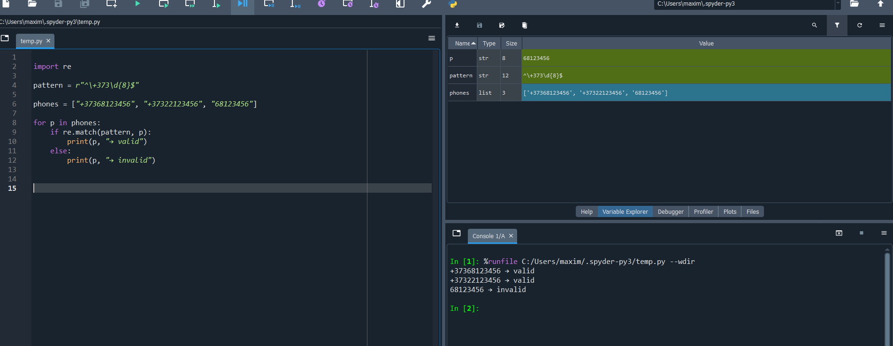

Codul 2 Extrage toate cuvintele care încep cu literă mare
Codul
import re

pattern_ip = r"""
\b(
25[0-5] | # 250–255
2[0-4]\d | # 200–249
1\d{2} | # 100–199
[1-9]?\d # 0–99
)
(\.
(
25[0-5] |
2[0-4]\d |
1\d{2} |
[1-9]?\d
)
){3}
\b
"""

text = "Serverele sunt 192.168.1.10 și 8.8.8.8, dar 999.999.999.999 nu este valid."

ips = re.findall(pattern_ip, text, re.VERBOSE)
print("IPv4 extrase:", ["".join(ip) for ip in ips])

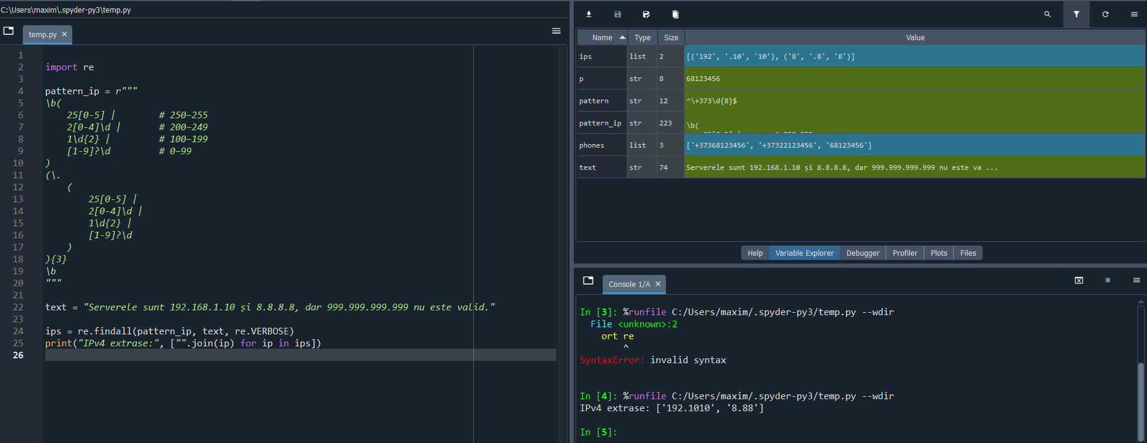
3) Identificarea uniformă a tagurilor HTML (inclusiv imbricate)
Codul
import re
pattern_html = r"<([a-zA-Z][a-zA-Z0-9]*)\b[^>]*>(.*?)<\/\1>"

html = """
<div class='box'>
<p>Salut, <b>Maxim</b>!</p>
</div>
"""
matches = re.findall(pattern_html, html, re.DOTALL)
print(matches)

